Mandatory Trainings, Learnings and Certifications in 2025:
- BTO Compliance: Following Hybrid Work Policy
- All Mandatory Trainings Completed
- Learning Hours (Target 180 Hrs) – Achieved 296 Hrs
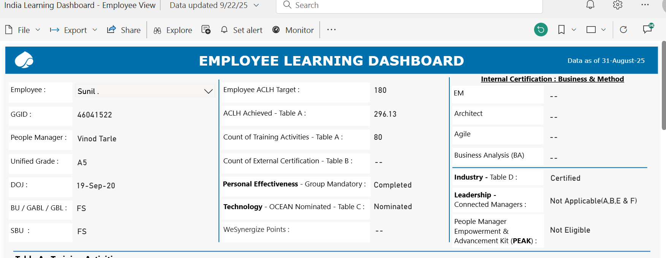



- Mandatory Certification:
1. OCEAN – JAVA – Beginner
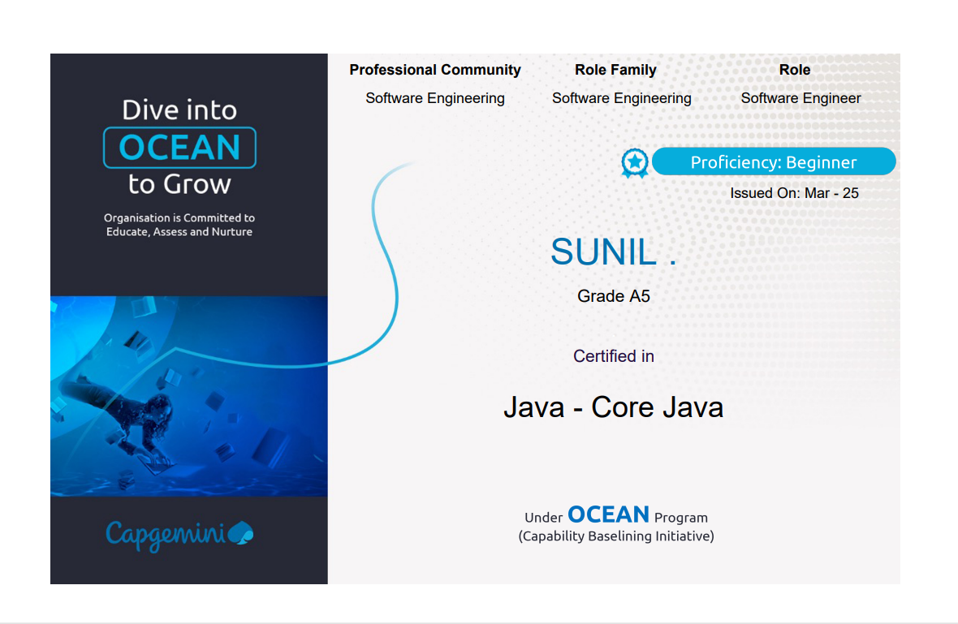

2. OCEAN – JAVA – Practitioner
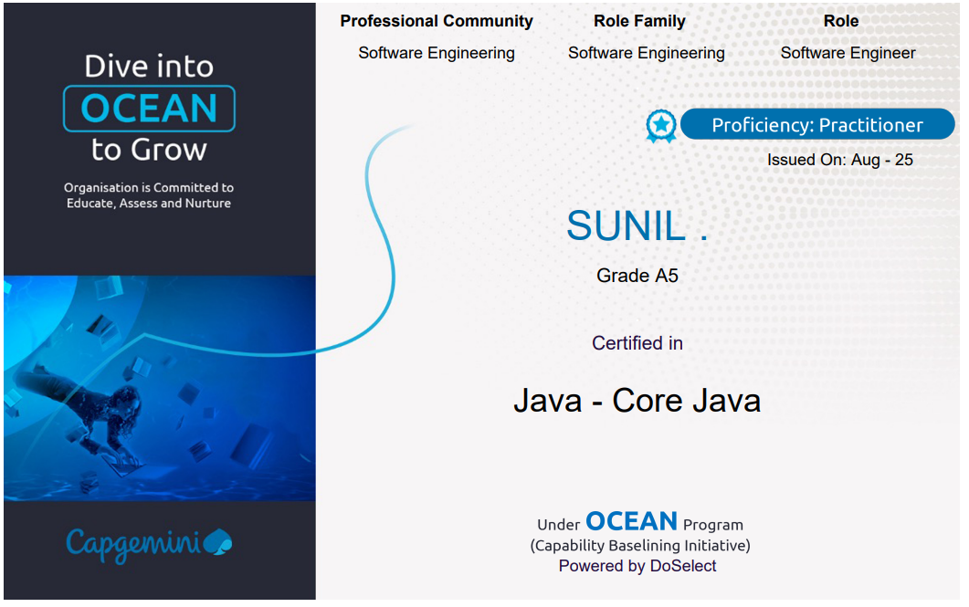

3. OCEAN – Android – Beginner
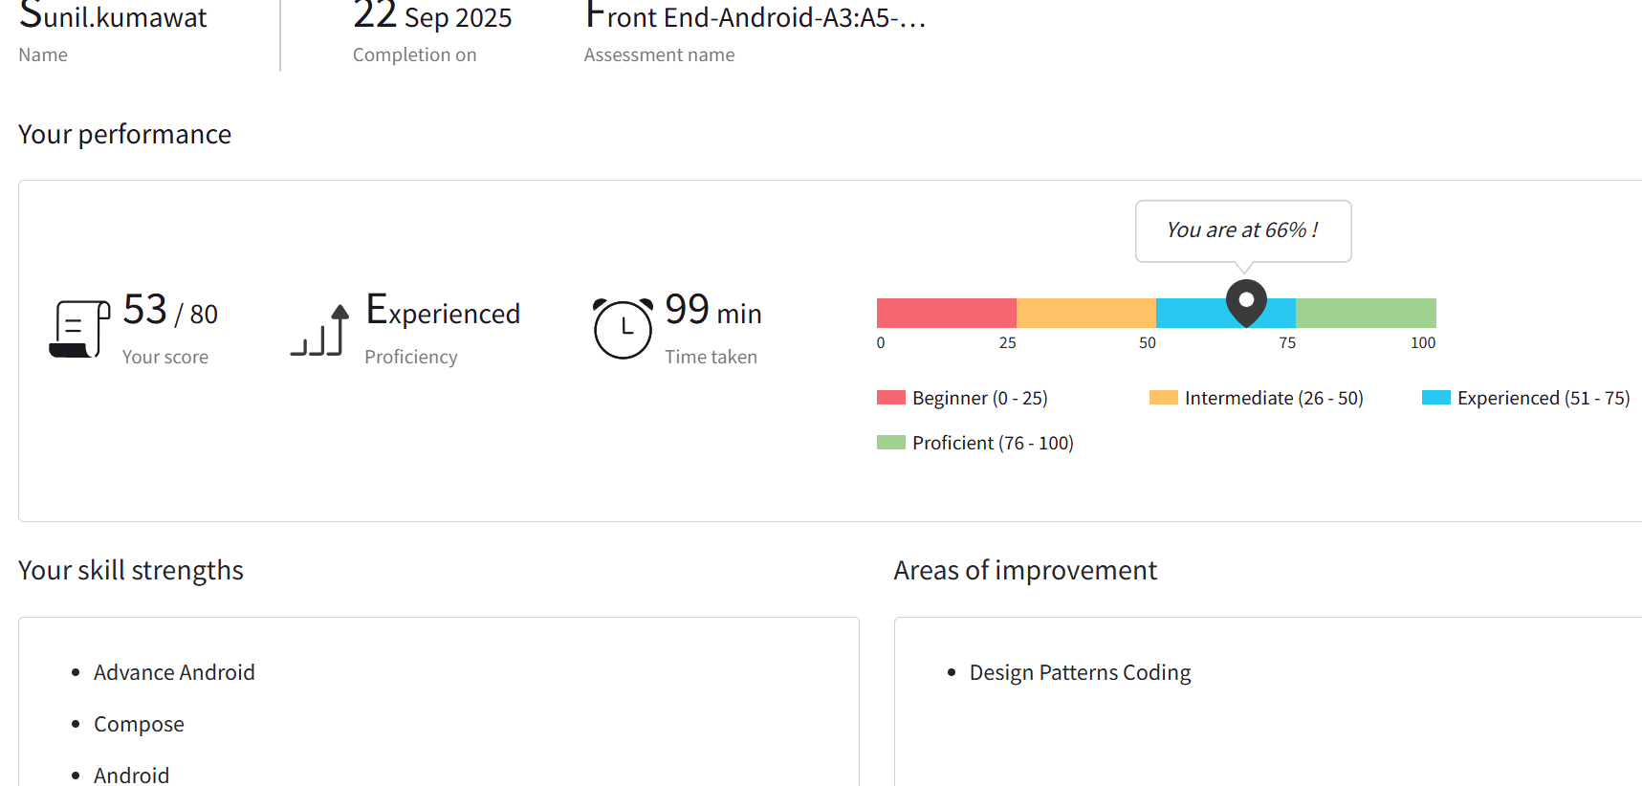

- BOOMBOX Training Completed: Mandatory Training by DCX practice
  - Communication and Leadership training – 4 sessions
- GitHub Copilot Training: April to August 2025 – HSBC Account
  - 1 week GitHub Copilot Training
  - 4 Assignment Completed given by Pilot
  - Gen AI and GitHub Copilot Mandatory Trainings Completed
  - Show And Tell Activity: Created Loan Management Android app and presented to DMs and DEs
  - Hackerrank Assessment completed
  - HSBC specific trainings
  - Prepared Gen AI Lab
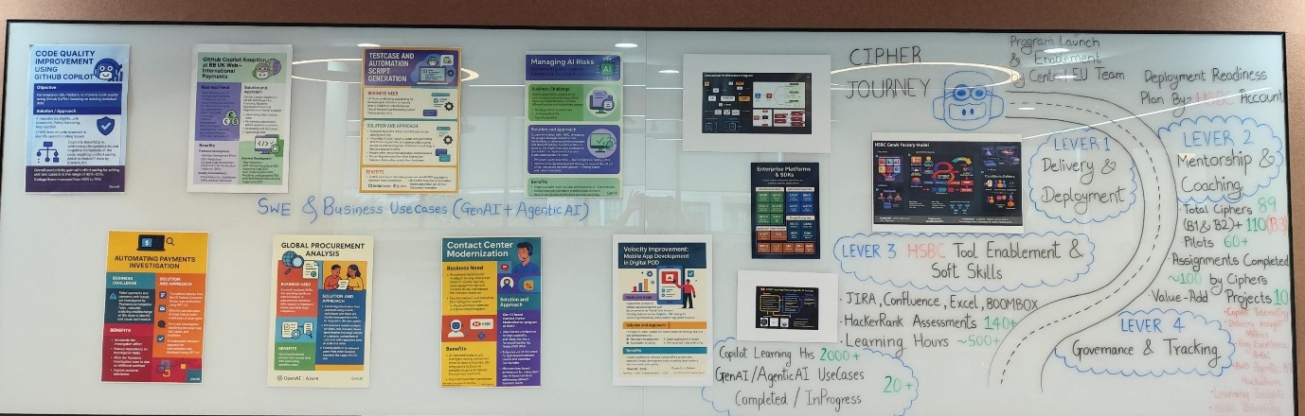
    - Appreciated by Senior Leadership for GenAI Lab
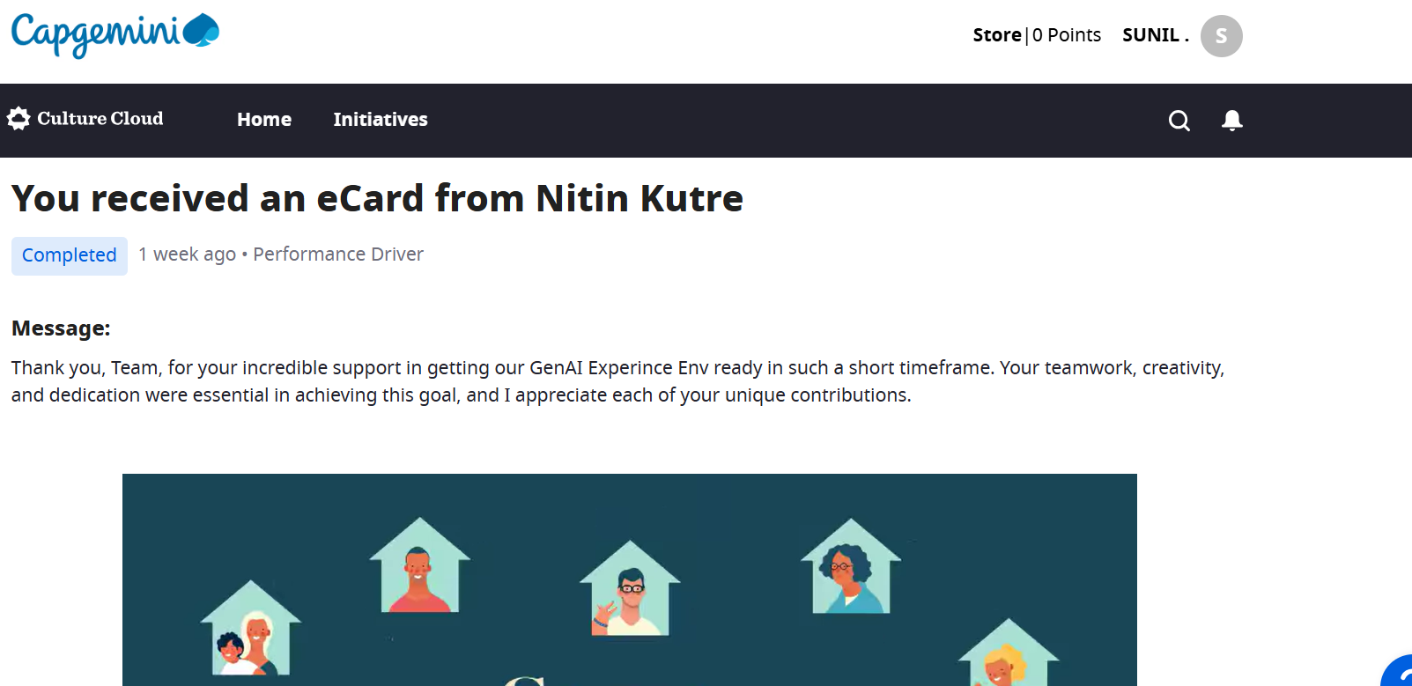

- Other Activities, Training and Certifications:
  - Participated in HSBC CSR Activity
  - Certificates
